**Dynamic Routing Failover**

**Topology**:

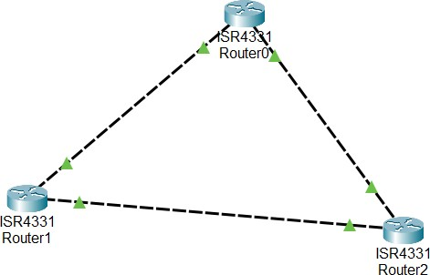

Fig 1. Topology of Routers

The topology with multiple routers and redundant paths was designed for enhanced reliability and fault tolerance. Redundant paths reduce the impact of failures, minimize downtime, and improve scalability. This configuration supports dynamic routing protocols, ensuring efficient routing and quick adaptation to changes. Additionally, it promotes business continuity, helps meet service level agreements, and provides opportunities for skill development in network management. Overall, the topology aims to create a robust and resilient network infrastructure in line with industry best practices.

# TASK 1: Set up OSPF on all routers

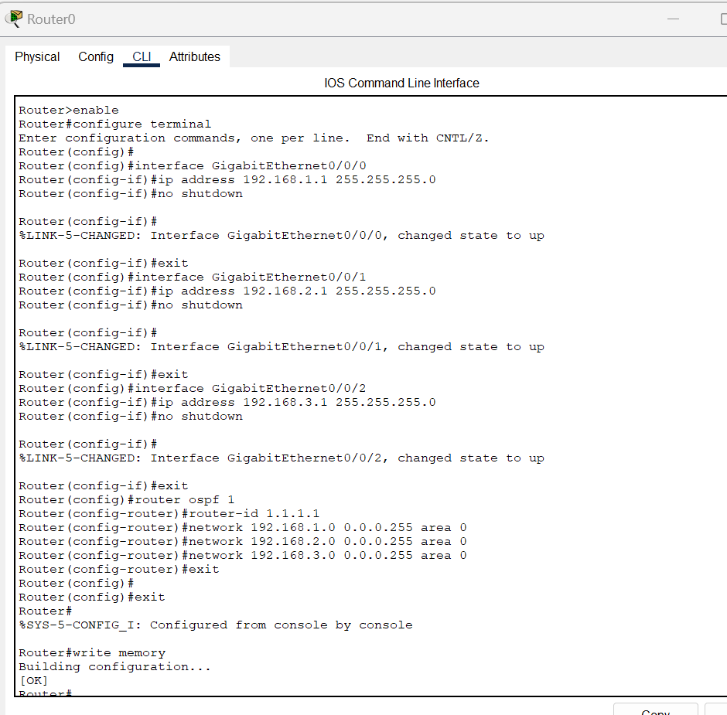

Fig 2. Router0 OSPF Configuration

# Enabled Privileged EXEC Mode:

* Entered a mode that allows for advanced configuration commands.

# Entered Global Configuration Mode:

* Entered a mode where you can configure various settings on the router.

# Configured Interfaces:

* Configured three interfaces: GigabitEthernet0/0/0, GigabitEthernet0/0/1, and GigabitEthernet0/0/2.
* Assigned IP addresses to each interface (192.168.1.1, 192.168.2.1, and 192.168.3.1) with corresponding subnet masks (255.255.255.0).
* Enabled each interface to bring them into an operational state.

# Configured OSPF (Open Shortest Path First):

* Entered OSPF configuration mode to set up dynamic routing.
* Assigned a router ID (1.1.1.1) to uniquely identify the router in the OSPF process.
* Defined network segments participating in OSPF (192.168.1.0, 192.168.2.0, and 192.168.3.0) and associated them with OSPF Area 0.

# Exited Global Configuration Mode and Saved Configuration:

* Exited the configuration mode.
* Saved the configured settings to ensure they persist after a reboot.

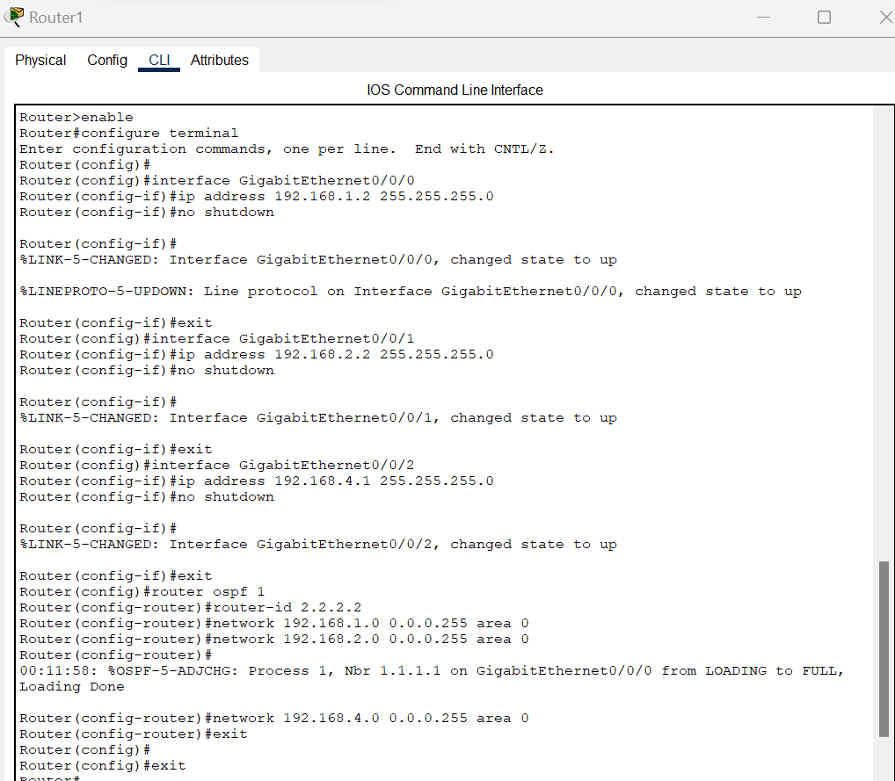

Fig 3. Router1 OSPF Configuration

# Enabled Privileged EXEC Mode:

* This mode grants access to advanced configurations.

# Entered Global Configuration Mode:

* A mode allowing you to configure various settings on the router.

# Configured Interfaces:

* Assigned IP addresses and subnet masks to three interfaces (GigabitEthernet0/0/0, GigabitEthernet0/0/1, and GigabitEthernet0/0/2).
* Enabled each interface to make them operational.

# Observed Interface Status Changes:

* The %LINK-5-CHANGED messages indicated changes in the state of the interfaces to "up."
* The %LINEPROTO-5-UPDOWN messages further confirmed changes in the line protocol status to "up."

# Configured OSPF (Open Shortest Path First):

* Entered OSPF configuration mode and assigned a router ID.
* Defined network segments participating in OSPF, associating them with OSPF Area 0.
* Received a %OSPF-5-ADJCHG message indicating a change in OSPF adjacency from LOADING to FULL, signaling successful OSPF neighbor establishment.

# Exited Global Configuration Mode and Saved Configuration:

* Exited the configuration mode.
* Saved the configuration to ensure persistence after a reboot.

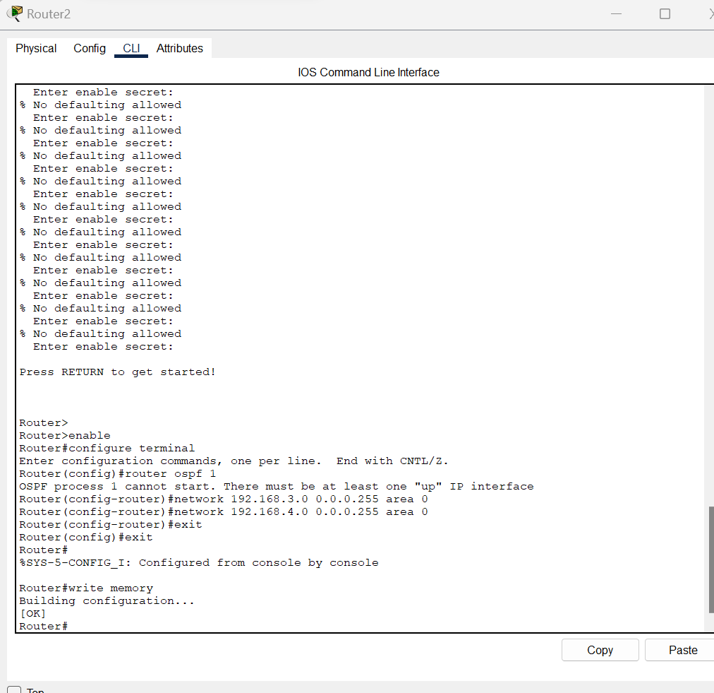

Fig 4. Router2 OSPF Configuration

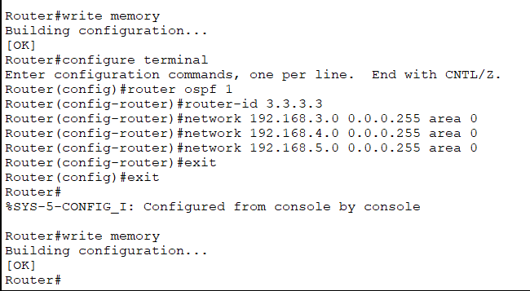

Fig 5. Router2 OSPF Configuration

# Enabled Privileged EXEC Mode:

* This mode grants access to advanced configurations.

# Entered Global Configuration Mode:

* In this mode, you can configure various settings on the router.

# Configured Interfaces:

* Assigned unique IP addresses (192.168.3.2, 192.168.4.2, and 192.168.5.2) with subnet masks (255.255.255.0) to three interfaces: GigabitEthernet0/0/0, GigabitEthernet0/0/1, and GigabitEthernet0/0/2.
* Enabled each interface to make them operational.
* Received messages indicating that the state and line protocol status of each interface changed to "up."

# Exited Interface Configuration Mode and Global Configuration Mode:

* Exited the configuration mode for each interface and then exited the global configuration mode.

# Syslog Message:

* Received a syslog message indicating that a configuration change was made through the console.

# Saved Configuration:

* Saved the configured settings to the router's memory, ensuring that changes persist after a reboot.

# Re-entered Global Configuration Mode and Configured OSPF:

* Returned to global configuration mode and entered OSPF configuration mode.
* Assigned a router ID of 3.3.3.3 to uniquely identify this router in the OSPF process.
* Defined network segments participating in OSPF (192.168.3.0, 192.168.4.0, and 192.168.5.0) and associated them with OSPF Area 0.

**TASK 2: Observe the routing table and established paths.**

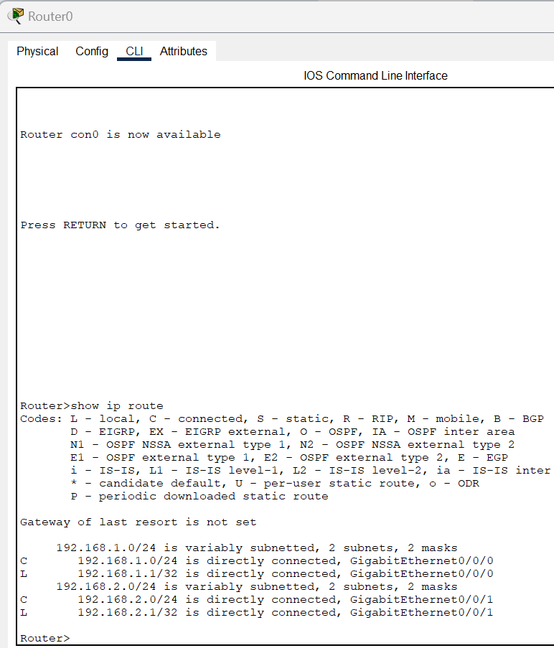

Fig 6. Router0 IP Route

* The router is directly connected to the 192.168.1.0/24 and 192.168.2.0/24 networks through GigabitEthernet0/0/0 and GigabitEthernet0/0/1 interfaces, respectively.
* Local IP addresses for these interfaces are 192.168.1.1/32 and 192.168.2.1/32.
* No default gateway is set.

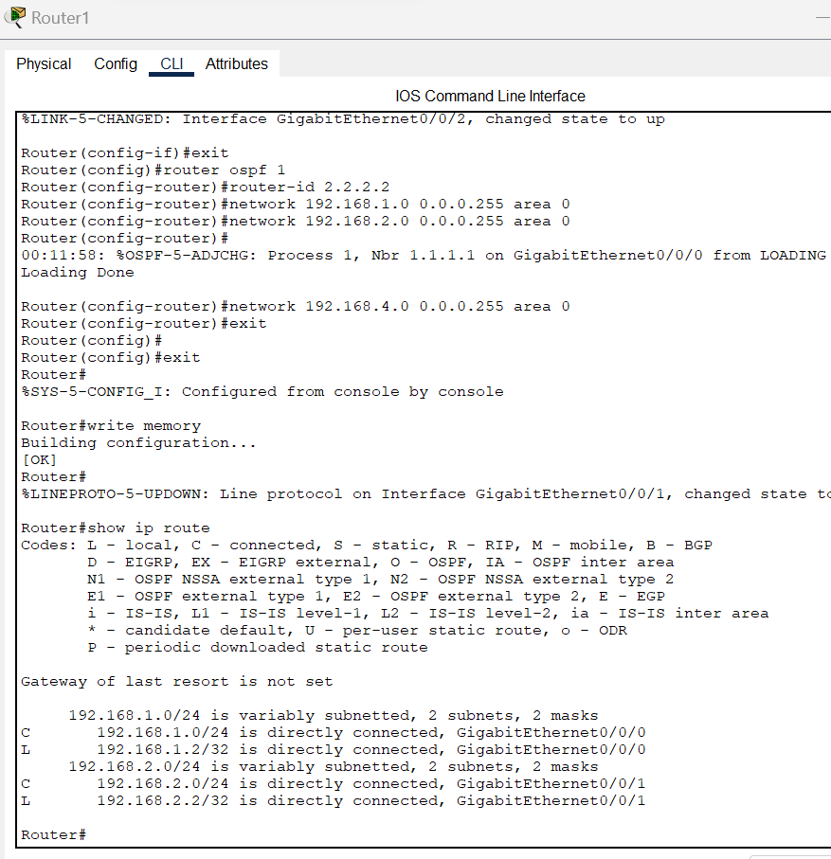

Fig 7. Router1 IP Route

* The router is directly connected to 192.168.1.0/24 and 192.168.2.0/24 networks via GigabitEthernet0/0/0 and GigabitEthernet0/0/1, respectively.
* Local IP addresses for these interfaces are 192.168.1.2/32 and 192.168.2.2/32.
* No default gateway is set.

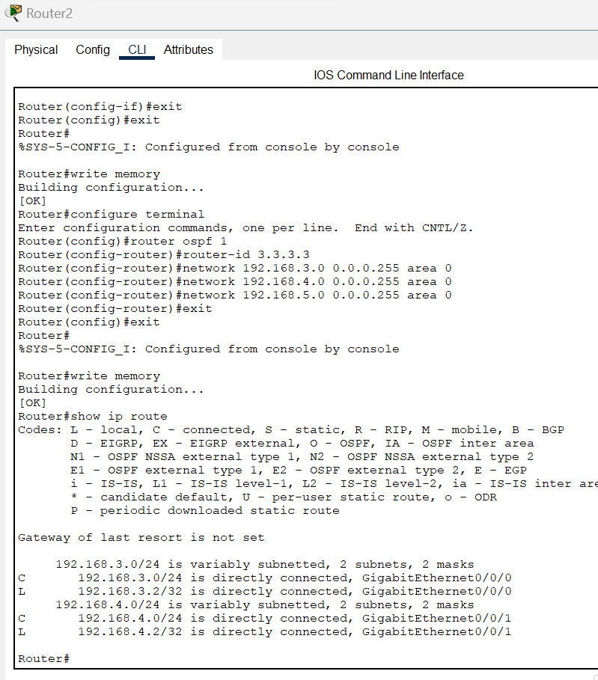

Fig 8. Router2 IP Route

* The router is directly connected to 192.168.3.0/24 and 192.168.4.0/24 networks via GigabitEthernet0/0/0 and GigabitEthernet0/0/1, respectively.
* Local IP addresses for these interfaces are 192.168.3.2/32 and 192.168.4.2/32.
* No default gateway is set.

STEP 3: Simulate a link failure and observe automatic route adjustments

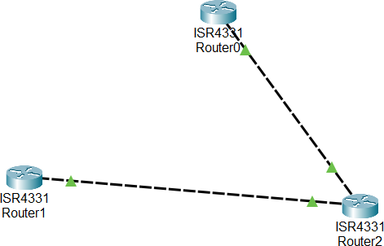

Fig 9. Link Removal

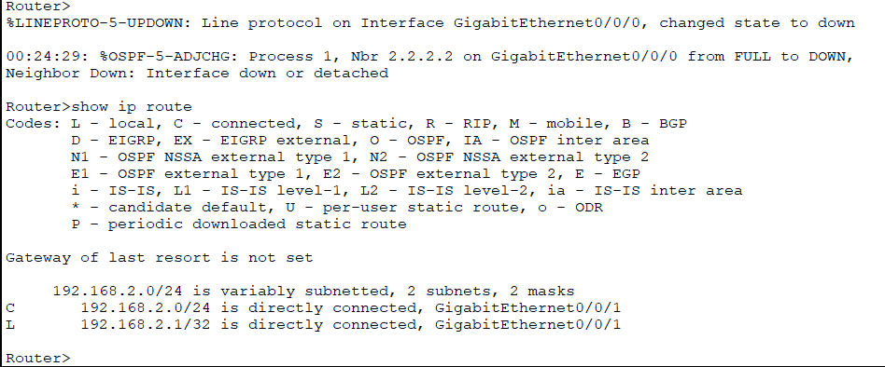

Fig 10. Router0 IP Route

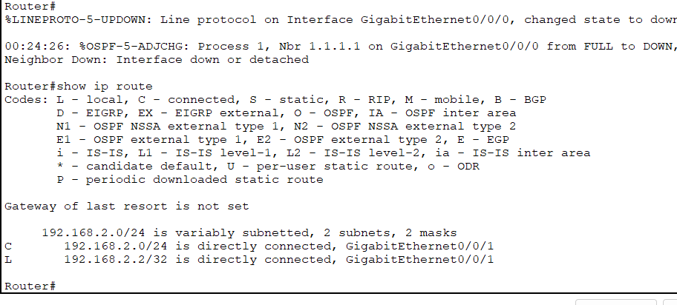

Fig 11. Router1 IP Route

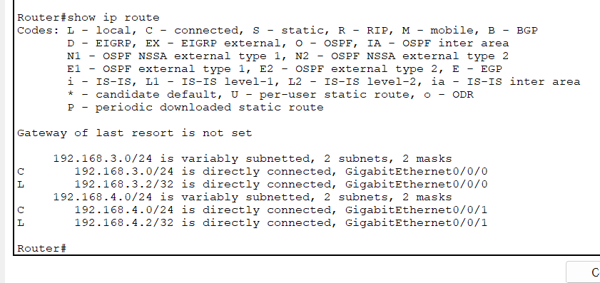

Fig 12. Router2 IP Route

In this simulation, I initiated a link failure and observed the automatic route adjustments in a network with three routers (Router0, Router1, and Router2). Here's a summary of the actions and outcomes:

# Router0:

* + The line protocol on Interface GigabitEthernet0/0/0 went down, triggering a change in state.
  + An OSPF adjacency change occurred with Router1 (Nbr 2.2.2.2) on GigabitEthernet0/0/0, transitioning from FULL to DOWN due to the interface being down or detached.
  + Checked the routing table using the "show ip route" command, revealing that only the directly connected network 192.168.2.0/24 remained.

# Router1:

* + Checked the routing table using the "show ip route" command after the link failure on Router0.
  + Similar to Router0, only the directly connected network 192.168.2.0/24 remained in the routing table.

# Router2:

* + Checked the routing table using the "show ip route" command after the link failure on Router0.
  + The routing table showed that only the directly connected networks 192.168.3.0/24 and 192.168.4.0/24 remained.

In essence, the simulation demonstrated the dynamic nature of OSPF routing. When the link failure occurred on Router0, OSPF automatically adjusted, and routers updated their routing tables to reflect the changed network topology. The routers adapted to the loss of connectivity and recalculated routes based on the remaining available paths.